The GenAI Augmentation Paradox: Evaluating Synthetic Data in Low-Data Image Classification

Akul Ameya
Bachelor of Data Science
S P Jain School of Global Management
Sydney, Australia
akul.bs23dmu006@spjain.edu.au
Nhat Quang Bui
Bachelor of Data Science
S P Jain School of Global Management
Sydney, Australia
quang.bs23dsy049@spjain.org
Aayush Aneja
Bachelor of Data Science
S P Jain School of Global Management
Sydney, Australia
aayush.bs23dmu002@spjain.org
Cahyani Karunia Putri
Bachelor of Data Science
S P Jain School of Global Management
Sydney, Australia
cahyani.bj24dsyu03@spjain.org

Abstract — We present a controlled study of diffusion-based synthetic data augmentation in a low-data image classification regime. Using Tiny ImageNet with 5% training data, we evaluate whether synthetic images generated by Stable Diffusion can recover performance and improve representation quality. We introduce a dose–response framework comparing Baseline, Uniform DiffusionBoost (5×, 10×, 15×), Adaptive DiffusionBoost, and a full-data Ceiling. Results show that performance improves at moderate synthetic budgets but saturates at larger scales, though all results are based on a single deterministic run and small differences should be interpreted cautiously. Adaptive allocation provides no significant advantage over uniform allocation, suggesting that the observed limitations are consistent with a quality-constrained synthetic distribution rather than allocation strategy alone. Multi-axis evaluation across accuracy, calibration, robustness, and representation geometry reveals that synthetic data improves feature structure but cannot substitute real data diversity. These findings formalize the GenAI augmentation paradox and position synthetic data as a limited but measurable tool in low-data regimes.
Keywords— Low-data classification, synthetic data augmentation, diffusion models, Tiny ImageNet, calibration (ECE), representation geometry, adaptive budget allocation, ResNet-18, MobileNetV3.

Problem Definition
Deep image classification models require large and diverse training data to generalize effectively. In low-data settings, fine-tuning pretrained models often leads to overfitting, poor calibration, and unstable representations. Recent advances in text-to-image diffusion models introduce a compelling hypothesis: synthetic images can supplement limited real data and recover performance.
Prior work shows that diffusion-generated images can improve classification when combined with real data, and that semantically meaningful augmentations benefit few-shot learning. However, existing studies typically evaluate a single synthetic budget, apply uniform augmentation across classes, and measure success primarily through aggregate accuracy. As a result, key questions remain unresolved: whether synthetic data provides genuine representation improvement, whether performance scales monotonically with synthetic volume, and whether class-aware allocation strategies offer advantages over uniform augmentation.
We address these questions through a controlled study on Tiny ImageNet under a 5% data regime (25 images per class). Synthetic images are generated using Stable Diffusion and incorporated under four pipelines: Baseline (real data only), Uniform DiffusionBoost (5×, 10×, 15× synthetic budgets), Adaptive DiffusionBoost (class-aware allocation at fixed budget), and a full-data Ceiling model. We extend the analysis by evaluating both cross-dataset generalization and loss-function modifications, enabling us to distinguish between data-driven and optimization-driven limitations of synthetic augmentation.
This work introduces a dose–response framework for synthetic data augmentation. We show that synthetic data provides measurable gains at moderate scale (+2.21 pp at 5×), but exhibits clear saturation beyond this point, with higher budgets yielding no improvement or slight degradation. Adaptive allocation strategies provide no consistent advantage over uniform allocation, suggesting that limitations are consistent with a constrained synthetic data distribution, rather than allocation strategy alone. Multi-axis evaluation further shows that while synthetic data improves representation structure, it cannot substitute for real data diversity in low-data regimes.

Related Work
Pretrained convolutional backbones provide the representational foundation for low-data classification. ResNet enables deep optimization through identity shortcuts [1], while MobileNetV3 extends this to efficient deployment via hardware-aware design [2]. Beyond accuracy, modern evaluation requires assessing calibration [3], representation similarity [4,5], robustness under distribution shift [6,7], and transferability from large-scale pretraining [8].
Diffusion models underpin the generative side of synthetic augmentation. Denoising diffusion probabilistic models [9] and their latent-space extensions [10] enable high-fidelity image synthesis, surpassing GAN-based approaches on quality benchmarks [11,12] while FID [13] remains the standard distributional similarity metric.
Recent work on diffusion-based augmentation converges on a consistent finding: synthetic data utility is highly conditional rather than monotonic. Multiple studies report classification gains when synthetic images are combined with real data [14–27], but these improvements depend critically on distributional alignment, intra-class diversity, and task relevance rather than volume alone. Synthetic samples well-aligned with target decision boundaries contribute meaningful signal, while poorly aligned or redundant samples introduce noise that degrades performance. This reframes synthetic augmentation from a scaling problem to a selection problem, where only subsets of synthetic data provide measurable benefit, and marginal returns diminish as additional samples fail to introduce new information.
A persistent gap remains between generative fidelity and discriminative utility. Visually realistic synthetic images do not necessarily improve downstream recognition, and transfer learning analyses consistently show that synthetic data fails to fully match the statistical properties of real data [28–30]. Classical augmentation methods such as RandAugment [31] remain competitive baselines, robustness evaluation relies on standardized benchmarks [32], and Tiny ImageNet [33] and CIFAR-100 [34] provide controlled experimental proxies. Broader surveys position diffusion-based methods as extensions of traditional augmentation pipelines [35] and emphasize calibration as a first-class evaluation dimension [36]. Scaling law analyses [37] suggest that performance improvements follow diminishing returns with increasing data, while prior synthetic–real domain gap studies [38] reinforce the distinction between image quality and downstream utility. Recent synthesis-oriented reviews confirm that the effect of synthetic data is highly conditional on generation, filtering, and integration strategy [39].
This gap motivates the present work, which introduces a dose–response framework demonstrating that performance gains follow a non-monotonic scaling law with clear saturation beyond moderate synthetic budgets.

Methodology

Problem Formulation
We study supervised image classification on Tiny ImageNet, consisting of 200 classes with images of resolution $x∈R^{3×64×64}$ and labels $y∈\left\{1,…,200\right\}$. To simulate a low-data regime, we retain only 5% of the training data (25 images per class, 5,000 total), which induces overfitting, poor calibration, and unstable representations. Performance is evaluated as a function of synthetic data budget in a dose–response framework, with a full-data ceiling model as the upper bound.

Synthetic Data Generation
Synthetic images are generated using Stable Diffusion v1.5 with fixed prompt templates derived from class labels. All images are generated once and cached to ensure full reproducibility across experiments. Generated images are resized to the dataset resolution (64×64) using Lanczos resampling prior to any training transformations, ensuring that synthetic and real images undergo identical preprocessing.
A maximum pool of 375 synthetic images per class (75,000 total) is constructed. Experimental budgets are defined as subsets of this pool: 5× (125 per class), 10× (250 per class), and 15× (375 per class).

Experimental Pipelines
We evaluate 4 pipelines:
- Baseline: model trained on 5% real data only
- Uniform DiffusionBoost: real data plus uniformly allocated synthetic images at 5×, 10×, and 15× budgets
- Adaptive DiffusionBoost: fixed total synthetic budget (15×), redistributed across classes using allocation policies
- Ceiling: model trained on 100% real data

Training Protocol
All models use ImageNet-pretrained backbones (ResNet-18 and MobileNetV3-Small) with the final classification layer adapted to 200 classes. Models are trained with standard optimization, augmentation, and regularization settings held constant across all pipelines. Early stopping is applied based on validation accuracy. For synthetic pipelines, a balanced sampler enforces approximately equal exposure to real and synthetic samples per epoch, preventing synthetic data from dominating the training distribution.
Experiments are conducted on a single GPU (RTX 4060) with deterministic sampling (seed 42). The Tiny ImageNet subset contains exactly 25 images per class. Synthetic datasets are pre-generated and reused across all runs.

Allocation Policies
Given a fixed total synthetic budget $B$, adaptive allocation redistributes samples across classes subject to bounds. Three policies are evaluated:
- Hard-class allocation: proportional to baseline per-class error
- Uncertainty-based allocation: proportional to prediction entropy
- Predicted-utility allocation: ridge regression predicting per-class accuracy gain using class-level features

Evaluation Framework
All models are evaluated across accuracy (Top-1, Top-5, macro, worst-20-class), calibration (ECE with temperature scaling), corruption robustness (noise, blur, brightness), per-class impact analysis (help–harm ratio), and representation geometry (effective rank and linear probe accuracy).

Synthetic Aware Loss (Ablation)
To evaluate whether distribution alignment affects performance, we introduce a synthetic-aware loss reweighting scheme.
For each synthetic sample, the feature-space distance to the real class centroid (computed from a frozen baseline model) is used to assign a weight $w_{i}=exp⁡\left(-λ*{dist}^{2}\right)$, where $λ=5.0$. The final loss is computed as a weighted cross-entropy $L=Σw_{i}*CE\left(y_{i},p_{i}\right)$, where $w_{i}=1$ for real samples and follows the exponential weighting for synthetic samples.

Experiments and Results

Accuracy and Synthetic Data Scaling
Table I presents the complete ResNet-18 results on Tiny ImageNet. The baseline achieves 49.44% Top-1 accuracy on the 5% real subset. Uniform DiffusionBoost at 5x budget yields the strongest improvement, reaching 51.65% — a gain of 2.21 percentage points. However, increasing the synthetic budget to 10x (49.98%) and 15x (49.85%) produces diminishing returns, with accuracy essentially plateauing near the baseline level. The full scaling curve is plotted in Fig. 2.
To contextualize the magnitude of synthetic gains, we report normalized improvement relative to the recoverable gap:
$$Normalized gain= \frac{{Acc}_{model}-{Acc}_{Baseline}}{{Acc}_{ceiling}-{Acc}_{Baseline}}$$
Under this metric, Uniform 5× achieves a normalized gain of 10.3%, recovering only a small fraction of the total achievable improvement, while higher budgets (e.g., 15×) recover less than 2%, confirming rapid saturation.
- ResNet-18 Tiny ImageNet Results
Pipeline | Top-1 (%) | Top-5 (%) | Macro (%) | Worst-20 (%) | ECE
Baseline | 49.44 | 75.59 | 49.44 | 16.3 | 0.151
Uniform 5x | 51.65 | 75.41 | 51.65 | 21.5 | 0.158
Uniform 10x | 49.98 | 74.56 | 49.98 | 20.4 | 0.057
Uniform 15x | 49.85 | 75.72 | 49.85 | 17.7 | 0.069
Adaptive HC 15x | 49.96 | 75.22 | 49.96 | 21.5 | 0.057
Adaptive Unc 15x | 49.99 | 75.21 | 49.99 | 20.2 | 0.058
Adaptive PU 15x | 49.29 | 74.90 | 49.29 | 21.4 | 0.039
Ceiling | 70.99 | 89.26 | 70.99 | 48.6 | 0.082
The ceiling model achieves 70.99%, establishing a gap of 21.55 percentage points from the baseline. These results reflect relative comparisons under a fixed experimental setup rather than statistically estimated population effects.
Synthetic scaling exhibits a clear saturation pattern. Performance improves at moderate budgets (5×), but additional synthetic data yields diminishing returns, with accuracy plateauing by 10× and slightly degrading at 15×. This behavior is consistent with training dynamics: augmented models converge faster and early-stop earlier, indicating rapid exhaustion of useful signal from the synthetic pool. Because the underlying synthetic distribution appears broadly consistent across budgets (as indicated by near-constant FID), additional samples are consistent with increasing redundancy or misalignment rather than introducing new semantic variation.
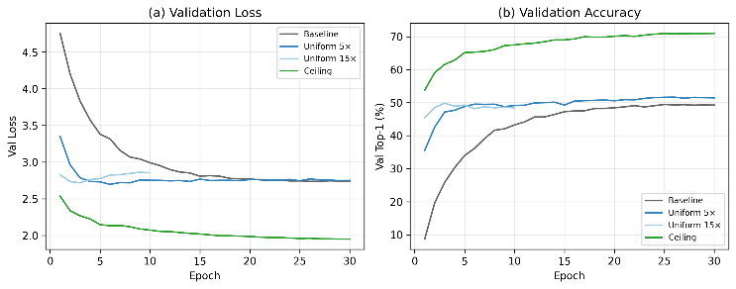
- Learning curves for Baseline, Uniform 5×, Uniform 15×, and Ceiling on Tiny ImageNet (ResNet-18). (a) Validation loss; (b) Validation accuracy. Augmented models converge faster but early-stop sooner, indicating rapid exhaustion of synthetic diversity.
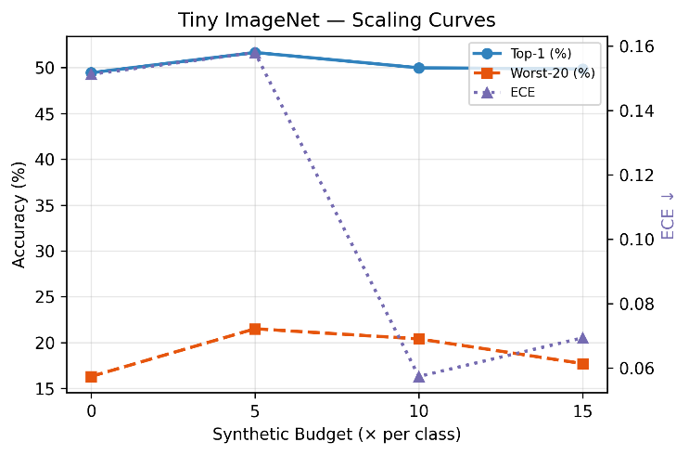
- Dose–response scaling curves showing Top-1 accuracy, Worst-20-class accuracy, and ECE as a function of synthetic budget (× per class). Accuracy peaks at 5× and saturates beyond 10×, while ECE decreases monotonically with budget.

Synthetic Distribution Quality (FID)
FID scores between the real training set and the synthetic pool are: 5× = 140.05, 10× = 139.61, 15× = 139.48. The near-constant FID across budgets confirms that increasing synthetic volume does not alter the underlying distributional alignment — additional images are drawn from the same generative manifold. However, FID is a global metric and does not capture class-conditional diversity or semantic alignment, so constant FID does not imply equal utility across samples. The moderately high FID reflects the resolution mismatch inherent in downsampling 512-pixel Stable Diffusion outputs to 64×64.

Allocation Policy Comparison
At the 15x total budget, all three adaptive policies perform within 0.7 percentage points of uniform allocation: hard-class (49.96%), uncertainty (49.99%), and predicted-utility (49.29%), compared to uniform (49.85%). No policy achieves a meaningful advantage within the observed range (≤1pp differences). A grouped comparison across multiple metrics is shown in Fig. 3.
This null result is informative. The predicted-utility ridge model achieves cross-validated R-squared of only 0.013, indicating that per-class utility — the accuracy gain from adding synthetic data — is nearly unpredictable from observable class properties. This suggests that the benefit of synthetic augmentation is governed by factors not captured in our feature set, such as the semantic alignment between text prompts and the visual concept, the internal representation quality of the diffusion model for each class, or stochastic training dynamics.
The worst-20-class metric provides a complementary perspective. While the baseline achieves only 16.30% on the 20 hardest classes, all DiffusionBoost variants improve this metric substantially: Uniform 5x reaches 21.50%, and adaptive hard-class also reaches 21.50%. This 5.2 percentage point improvement on tail classes suggests that synthetic augmentation benefits the most data-starved classes disproportionately, even when aggregate accuracy gains are modest.
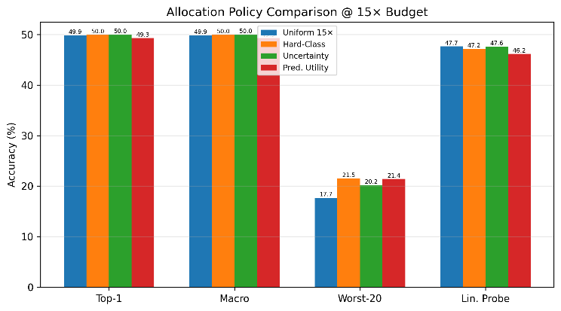
- Allocation policy comparison at 15× budget across Top-1, Macro, Worst-20, and Linear Probe accuracy. No policy achieves a statistically meaningful advantage over uniform allocation.

Per-Class Analysis
Per-class accuracy deltas reveal that synthetic augmentation is not uniformly beneficial (Fig. 4). Under Uniform 5x, 106 of 200 classes are helped (delta > 2pp), 25 are neutral, and 69 are harmed (delta < -2pp). At the 15x budget, the balance shifts: 90 classes are helped, 20 neutral, and 90 harmed. To summarize per-class effects, we define a Help–Harm Ratio (HHR):
$$HHR=\frac{\#helped-\#harmed}{total classes}$$
At 5×, HHR = (106 − 69) / 200 = 0.185, indicating a net positive effect. At 15×, HHR = (90 − 90) / 200 = 0.0, confirming that gains disappear at higher synthetic budgets and that additional samples introduce as much harm as benefit.
The shift from a net-positive to balanced help/harm ratio suggests that additional synthetic data increasingly introduces class-specific misalignment, degrading performance for a subset of classes.
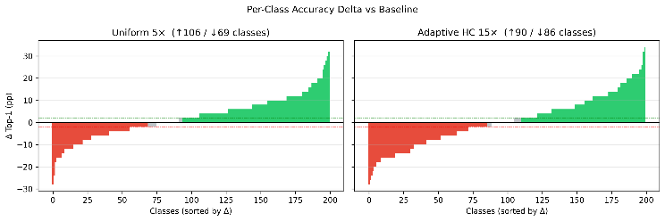
- Per-class accuracy delta (pp) vs Baseline for Uniform 5× (left) and Adaptive HC 15× (right). Green bars indicate classes helped (>2pp), red bars indicate classes harmed (<-2pp). The help/harm ratio deteriorates with increasing budget.

Calibration and Temperature Scaling
The baseline model exhibits substantial overconfidence (ECE = 0.151), consistent with findings from Guo et al. [11] on calibration of modern neural networks. DiffusionBoost at moderate budgets substantially improves raw calibration: Uniform 10x achieves ECE = 0.057, a 62% reduction (see ECE axis in Fig. 2). This improvement is partly attributable to the regularization effects of synthetic data diversity and label smoothing (0.1), which softens the model's confidence distribution.
Post-hoc temperature scaling brings all models to comparable calibrated ECE values between 0.024 and 0.038. The baseline's optimal temperature (T = 0.754) is notably lower than that of augmented models (T = 0.855), indicating that the augmented models require less aggressive recalibration. This suggests that synthetic augmentation reduces overconfidence; however, improvements may partially reflect lower predictive confidence or accuracy–confidence coupling effects rather than strictly improved probabilistic correctness.
- Calibration Results (Raw ECE / Temperature T / Calibrated ECE)
Pipeline | Raw ECE | T | Cal. ECE
Baseline | 0.151 | 0.754 | 0.024
Uniform 5x | 0.158 | 0.754 | 0.038
Uniform 10x | 0.057 | 0.855 | 0.030
Uniform 15x | 0.069 | 0.855 | 0.032
Adaptive HC 15x | 0.057 | 0.855 | 0.030
Adaptive Unc 15x | 0.058 | 0.855 | 0.038
Adaptive PU 15x | 0.039 | 0.956 | 0.034
Ceiling | 0.082 | 0.754 | 0.036
The predicted-utility adaptive policy achieves the best raw ECE (0.039), although this may partly reflect its slightly lower accuracy — less confident predictions are mechanically better calibrated. The ceiling model (ECE = 0.082) is moderately well-calibrated, reflecting the beneficial effect of abundant real training data.
Thus, calibration improvements should be interpreted as reductions in overconfidence rather than strictly improved probability estimation.

Corruption Robustness
- Corruption Robustness (Accuracy %)
Pipeline | Clean | Noise | Blur | Brightness | Mean Corrupt
Baseline | 49.44 | 17.03 | 48.18 | 47.40 | 37.54
Uniform 5x | 51.65 | 5.51 | 50.42 | 49.74 | 35.22
Uniform 10x | 49.98 | 9.38 | 49.13 | 47.70 | 35.40
Uniform 15x | 49.85 | 8.85 | 48.96 | 47.92 | 35.24
Adaptive HC 15x | 49.96 | 9.53 | 48.88 | 47.39 | 35.27
Adaptive Unc 15x | 49.99 | 6.40 | 49.33 | 47.79 | 34.51
Adaptive PU 15x | 49.29 | 7.42 | 48.92 | 46.68 | 34.34
Ceiling | 70.99 | 4.36 | 69.69 | 69.43 | 47.83
Corruption analysis reveals a nuanced trade-off (Fig. 5). DiffusionBoost models maintain or slightly improve accuracy under blur and brightness corruptions relative to baseline: Uniform 5x achieves 50.42% under blur (vs 48.18% baseline) and 49.74% under brightness (vs 47.40%). However, all augmented models exhibit substantially degraded noise robustness: Uniform 5x drops to 5.51% under Gaussian noise, compared to 17.03% for baseline — a 69% relative degradation.
This noise sensitivity is not specific to synthetic augmentation. The ceiling model, trained on 100% real data, shows even lower noise accuracy (4.57%). The pattern suggests that models with higher clean accuracy — whether achieved through more real or synthetic data — learn finer discriminative features that are disproportionately disrupted by additive noise. This is consistent with the known accuracy-robustness trade-off in neural networks.
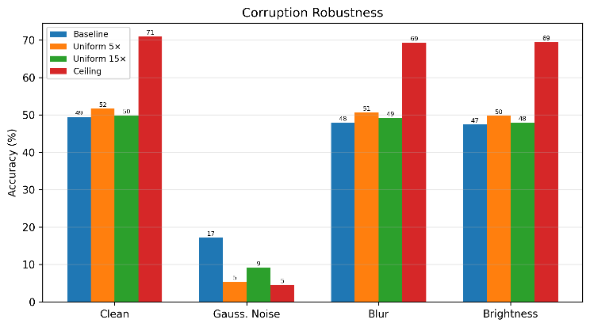
- Corruption robustness across clean, Gaussian noise, blur, and brightness conditions for Baseline, Uniform 5×, Uniform 15×, and Ceiling (ResNet-18). Synthetic augmentation improves blur/brightness robustness but degrades noise robustness.

Representation Geometry
Representation analysis provides evidence that synthetic augmentation improves feature separability under linear probing beyond what accuracy alone captures. The eigenvalue spectra of all pipelines are compared in Fig. 6.
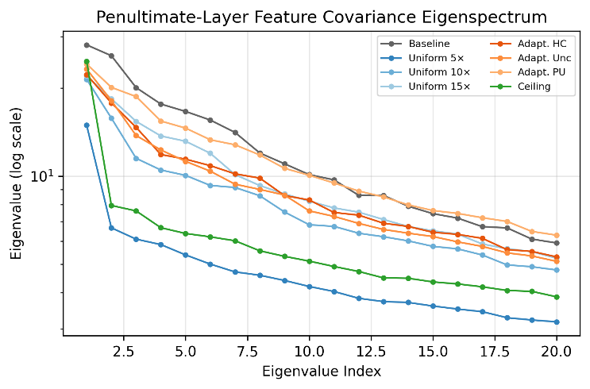
- Representation geometry across pipelines showing eigenvalue spectra and feature distribution characteristics. Synthetic augmentation increases effective rank and improves feature separability relative to baseline.
- Representation Geometry (ResNet-18)
Pipeline | Lin. Probe (%) | Eff. Rank
Baseline | 46.06 | 31.77
Uniform 5x | 49.18 | 35.83
Uniform 10x | 48.12 | 34.49
Uniform 15x | 47.66 | 33.66
Adaptive HC 15x | 47.16 | 34.38
Adaptive Unc 15x | 47.60 | 34.06
Adaptive PU 15x | 46.16 | 34.05
Ceiling | 64.02 | 34.10
Linear probe accuracy, which evaluates feature quality independently of the classification head by training a fresh logistic regression on frozen penultimate-layer features, shows a clear benefit from synthetic augmentation. Uniform 5x achieves 49.18% probe accuracy versus 46.06% for baseline — a 3.12pp improvement that exceeds the Top-1 accuracy gap (2.21pp). This indicates that synthetic data improves linear separability of learned feature representations beyond what the fine-tuned classifier exploits. The summary comparison of Top-1 and linear probe accuracy across all pipelines is shown in Fig. 7.
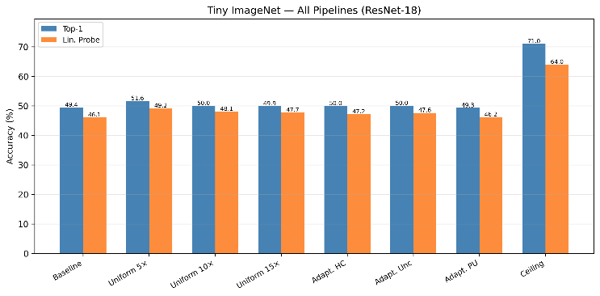
- Summary bar chart comparing Top-1 accuracy and linear probe accuracy across all Tiny ImageNet pipelines (ResNet-18). Linear probe gains persist even at budgets where Top-1 accuracy has saturated.
The effective rank of the feature covariance matrix increases from 31.77 (baseline) to 35.83 (Uniform 5x), indicating that synthetic augmentation encourages the model to utilize a higher-dimensional feature space. The ceiling model's effective rank (34.10) is comparable to the augmented models, suggesting that synthetic data approaches the effective rank observed in the ceiling model. Notably, effective rank increases persist even when accuracy plateaus, indicating that improved feature utilization does not necessarily translate to better classification.

Architecture Comparison
MobileNetV3-Small (2.5M parameters, approximately one-fifth the size of ResNet-18) serves as a cross-architecture validation. On the 5% real subset, MobileNetV3-Small achieves a baseline Top-1 accuracy of 50.31% (Top-5: 77.69%), marginally exceeding ResNet-18 (49.44%). This slightly superior low-data performance likely reflects MobileNetV3's inverted residual blocks with squeeze-and-excitation, which provide a stronger inductive bias for the limited training data.
Notably, MobileNetV3-Small benefits more from synthetic augmentation than ResNet-18. At Uniform 15x, MobileNetV3-Small reaches 55.21% Top-1 (vs 49.85% for ResNet-18 at the same budget), a gain of 4.90pp over its baseline compared to only 0.41pp for ResNet-18. Adaptive PU 15x achieves a comparable 55.03%. This suggests that the lighter architecture, with its stronger inductive bias, can extract more useful signal from the synthetic distribution before saturating.
- MobileNetV3-Small Tiny ImageNet Results
Pipeline | Top-1 (%) | Top-5 (%) | Macro (%) | Worst-20 (%) | ECE
Baseline | 50.31 | 77.69 | 50.31 | 18.40 | 0.094
Uniform 15x | 55.21 | 79.66 | 55.21 | 26.40 | 0.039
Adaptive PU 15x | 55.03 | 79.84 | 55.03 | 27.60 | 0.055
Ceiling | 71.69 | 90.56 | 71.69 | 48.00 | 0.102
- MobileNetV3-Small Calibration
Pipeline | Raw ECE | T | Cal. ECE
Baseline | 0.094 | 0.855 | 0.021
Uniform 15x | 0.039 | 0.956 | 0.016
Adaptive PU 15x | 0.055 | 0.855 | 0.028
Ceiling | 0.102 | 0.754 | 0.017
- MobileNetV3-Small Corruption Robustness (Accuracy %)
Pipeline | Clean | Noise | Blur | Brightness | Mean Corrupt
Baseline | 50.31 | 8.10 | 49.58 | 48.70 | 35.46
Uniform 15x | 55.21 | 6.43 | 55.17 | 53.27 | 38.29
Adaptive PU 15x | 55.03 | 4.95 | 55.11 | 53.38 | 37.81
Ceiling | 71.69 | 8.45 | 71.23 | 69.95 | 49.88
- MobileNetV3-Small Representation Geometry
Pipeline | Lin. Probe (%) | Eff. Rank
Baseline | 44.44 | 30.73
Uniform 15x | 47.46 | 32.83
Adaptive PU 15x | 47.08 | 32.76
Ceiling | 54.34 | 34.40
The ceiling model achieves 71.69% Top-1 for MobileNetV3-Small, closely mirroring the ResNet-18 ceiling (70.99%). The gap recovered by Uniform 15x is 4.90 of 21.38pp (22.9%), substantially more than the 1.9% recovery observed for ResNet-18 at the same budget. This cross-architecture difference reinforces that the saturation point depends on the interaction between model capacity and synthetic data diversity, not solely on the synthetic distribution itself.
The consistency of the scaling pattern across architectures suggests that the observed saturation behavior is not architecture-specific, but reflects properties of the synthetic data distribution and training regime.

Loss Function Ablation on TinyImageNet
To test whether the observed limitations of synthetic augmentation arise partly from optimization rather than data quality alone, we replace standard cross-entropy (CE) with the proposed SA loss while keeping all other components fixed. We evaluate this on the two most informative 15× settings: Uniform 15× and Adaptive Predicted-Utility 15×.
Fig 8. compares CE and SA on Tiny ImageNet. If SA improves both settings, this indicates that part of the limitation of synthetic augmentation is optimization-driven. If SA yields only marginal improvement or preserves the same saturation pattern, the result suggests that the dominant limitation is consistent with the synthetic data distribution itself rather than the loss formulation alone.

- Fig. 8. CE vs SA loss comparison on Tiny ImageNet (ResNet-18) for Uniform 15× and Adaptive PU 15× pipelines. SA does not materially alter accuracy or linear probe performance, suggesting the saturation limitation is data-driven rather than optimization-driven.
SA does not materially alter the observed ranking or saturation pattern, suggesting that the limitation is not primarily due to loss formulation.

Contextual Comparison with Prior Work
To contextualize the observed performance, we compare our results to representative findings from prior work on diffusion-based augmentation and low-data classification. Recent studies report that synthetic data can improve ImageNet classification by several percentage points when combined with real data under standard training regimes [14], while diffusion-based augmentation in few-shot settings has demonstrated consistent but modest gains [16].
In our controlled low-data setting, the best-performing configuration (Uniform 5×) achieves a +2.21 percentage point improvement over baseline, corresponding to approximately 10.3% recovery of the gap to the full-data ceiling. This magnitude is consistent with prior findings that synthetic data provides incremental rather than transformative gains, particularly when the underlying distribution remains fixed.
Importantly, unlike many prior studies that evaluate a single augmentation regime, our dose–response framework reveals a non-monotonic scaling behavior with clear saturation beyond moderate synthetic budgets. This provides a more complete characterization of synthetic data utility, showing that increasing volume alone does not guarantee continued performance improvement.
Furthermore, our results align with recent observations that synthetic data effectiveness is highly conditional, depending on distribution alignment, diversity, and task relevance [27,35]. The lack of improvement from adaptive allocation strategies suggests that limitations arise from the synthetic data distribution itself rather than allocation inefficiency, reinforcing the distinction between generative fidelity and discriminative utility observed in prior work [28–30].

Cross-Dataset Validation (CIFAR-100)
To test whether the observed dose–response behavior is specific to Tiny ImageNet, we repeat the core synthetic-scaling experiment on CIFAR-100. Fig 9. summarizes the CIFAR-100 results across the main pipelines.
The CIFAR-100 results provide a cross-dataset validation of the central finding. If the same non-monotonic pattern is observed, this supports the claim that moderate synthetic augmentation can help while larger budgets saturate or degrade. If the pattern weakens or changes, it indicates that synthetic augmentation utility is also dataset-dependent.

- CIFAR-100 summary across the main pipelines. This figure tests whether the dose–response pattern observed on Tiny ImageNet generalizes to a second benchmark.
Unlike Tiny ImageNet, this section is included to assess generalization of the scaling pattern rather than to repeat the full analysis across all evaluation axes.

Loss Function Transfer on CIFAR-100
We further evaluate whether the effect of SA transfers to a second dataset. Fig. 10 compares CE and SA on CIFAR-100 under the corresponding synthetic augmentation setting.
This test separates dataset-level generalization from optimization-level generalization. If SA produces consistent gains on both Tiny ImageNet and CIFAR-100, the loss modification is likely capturing a broader training effect. If it helps only on one dataset, the benefit is more likely regime-specific.

- CIFAR-100 SA ablation comparing CE and SA under synthetic augmentation. This tests whether the optimization effect of SA generalizes beyond Tiny ImageNet.
Unlike Tiny ImageNet, this section is included to assess generalization of the scaling pattern rather than to repeat the full analysis across all evaluation axes.
All results are based on a single deterministic run; differences below approximately 1 percentage point should be interpreted cautiously.

Discussion
Our results establish the GenAI Augmentation Paradox: diffusion-generated synthetic data provides measurable but fundamentally bounded benefits in low-data image classification, following a non-monotonic dose–response curve rather than scaling linearly with volume.
The dominant mechanism is bounded diversity within the synthetic distribution. At low budgets, synthetic samples introduce complementary variations absent from the small real dataset. As the budget increases, additional samples become redundant or semantically misaligned, as confirmed by near-constant FID across budgets. Because all images are generated from a fixed model and prompt space, marginal information gain rapidly decreases. In some cases, excessive synthetic exposure biases representations toward generative artifacts, degrading class-specific discrimination.
Ablation results reinforce this interpretation. Adaptive allocation policies fail to improve over uniform augmentation, indicating that limitations arise from synthetic data quality and diversity rather than allocation inefficiency. The SA loss ablation preserves the same saturation pattern, suggesting the bottleneck is data-distributional rather than optimization-driven. The ceiling gap further confirms that real data provides critical information — fine-grained texture, pose variation, and contextual cues — that text-conditioned diffusion models do not reliably capture at low resolution.
Despite limited accuracy gains, synthetic augmentation acts as a regularizer on predictive confidence, producing consistent calibration improvements. Representation analysis reveals a further dissociation: linear probe accuracy continues to improve at budgets where Top-1 accuracy has saturated, suggesting that synthetic data enhances intermediate feature representations in ways the classifier head does not fully exploit. This has implications for transfer learning, where feature quality matters more than task-specific accuracy.
Cross-architecture validation confirms these findings are not backbone-specific. MobileNetV3-Small exhibits the same qualitative pattern with a higher saturation point, suggesting architectures with stronger inductive biases extract more from the same synthetic distribution before saturating.
Several limitations apply. All results are based on a single deterministic run, so differences below approximately 1pp should be interpreted cautiously. FID is a global metric and does not capture class-conditional diversity or semantic correctness. No quality filtering or sample selection is applied to synthetic data. Experiments are conducted at 64×64 resolution, where downsampling from high-resolution diffusion outputs may introduce artifacts. Finally, the study evaluates a single generative model with fixed prompt templates; improved generative diversity or adaptive prompting may shift the saturation point.

Conclusion
We have conducted a controlled multi-axis evaluation of diffusion-based synthetic data augmentation for low-data image classification on Tiny ImageNet. Our findings establish three principal conclusions. First, synthetic augmentation follows a dose-response curve with clear diminishing returns: a modest 5x budget produces the largest accuracy gain (2.21pp), while higher budgets (10x, 15x) yield no additional improvement (Fig. 2), though these differences are observed under a single deterministic seed and should be interpreted as directional rather than statistically confirmed. Second, at saturation budget levels, adaptive allocation policies (hard-class, uncertainty, predicted-utility) do not meaningfully outperform uniform allocation, because the marginal value of synthetic data is uniformly low when the synthetic pool's diversity has been exhausted (Fig. 3). Third, synthetic augmentation improves model calibration and feature representation quality even when Top-1 accuracy gains are modest, as evidenced by reduced ECE, higher effective rank, and improved linear probe accuracy (Fig. 6, Fig. 8).
These results reframe the synthetic augmentation question from "Does synthetic data help?" to "How much synthetic data helps, and under what conditions?" The answer, at least for text-conditioned diffusion models at 64x64 resolution in a 5% data regime, is: a little helps, more does not, and the ceiling gap remains substantial. Proving this limitation is as valuable as achieving a new high score, as it provides practitioners with actionable guidance on when and how much to invest in synthetic data generation.
Future work should investigate whether higher-fidelity generative models, adaptive prompting strategies, or image-conditioned synthesis can push the saturation point further. Testing adaptive allocation at lower synthetic budgets (where we hypothesize it would be more effective) and extending the study to additional datasets (CIFAR-100, specialized domains) would strengthen the generalizability of our conclusions.

References
- K. He, et al., “Deep residual learning for image recognition,” in Proc. IEEE Conf. Comput. Vis. Pattern Recognit. (CVPR), 2016.
- A. Howard, et al., “Searching for MobileNetV3,” in Proc. IEEE/CVF Int. Conf. Comput. Vis. (ICCV), 2019.
- C. Guo, et al., “On calibration of modern neural networks,” in Proc. Int. Conf. Mach. Learn. (ICML), 2017.
- S. Kornblith, et al., “Similarity of neural network representations revisited,” in Proc. Int. Conf. Mach. Learn. (ICML), 2019.
- T. Cui, et al., “Deconfounded representation similarity for comparison of neural networks,” in Adv. Neural Inf. Process. Syst. (NeurIPS), 2022.
- M. Wortsman, et al., “Robust fine-tuning of zero-shot models,” in IEEE/CVF Conference on Computer Vision and Pattern Recognition (CVPR), 2022.
- S-A Rebuffi, et al., “Data augmentation can improve robustness,” in NeurIPS, 2021.
- J. Deng, et al., “ImageNet: A large-scale hierarchical image database,” in Proc. IEEE Conf. Comput. Vis. Pattern Recognit. (CVPR), 2009.
- J. Ho, A. Jain, and P. Abbeel, “Denoising diffusion probabilistic models,” in Adv. Neural Inf. Process. Syst. (NeurIPS), 2020.
- R. Rombach, et al., “High-resolution image synthesis with latent diffusion models,” in Proc. IEEE/CVF Conf. Comput. Vis. Pattern Recognit. (CVPR), 2022.
- P. Dhariwal and A. Nichol, “Diffusion models beat GANs on image synthesis,” in Adv. Neural Inf. Process. Syst. (NeurIPS), 2021.
- J. Ho and T. Salimans, “Classifier-free diffusion guidance,” arXiv preprint arXiv:2207.12598, 2022.
- M. Heusel, et al., “GANs trained by a two time-scale update rule converge to a local Nash equilibrium,” in Adv. Neural Inf. Process. Syst. (NeurIPS), 2017.
- S. Azizi, et al., “Synthetic data from diffusion models improves ImageNet classification,” Trans. Mach. Learn. Res., 2023.
- G. Koh, et al., “Synthetic data augmentation using pre-trained diffusion models for long-tailed food image classification,” in Proc. IEEE/CVF Conf. Comput. Vis. Pattern Recognit. Workshops (CVPRW), 2025.
- B. Trabucco, et al., “Effective data augmentation with diffusion models,” in Proc. Int. Conf. Learn. Representations (ICLR), 2024.
- J. M. Kim, et al., “DataDream: Few-shot guided dataset generation,” in Proc. Eur. Conf. Comput. Vis. (ECCV), 2024.
- V. G. Turrisi da Costa, et al., “Diversified in-domain synthesis with efficient fine-tuning for few-shot classification,” arXiv preprint arXiv:2312.03046, 2023.
- L. Boudier, et al., “Training-free synthetic data generation with dual IP-Adapter guidance,” in Proc. Brit. Mach. Vis. Conf. (BMVC), 2025.
- M. B. Sariyildiz, et al., “Fake it till you make it: Learning transferable representations from synthetic ImageNet clones,” in Proc. IEEE/CVF Conf. Comput. Vis. Pattern Recognit. (CVPR), 2023.
- R. A. Bafghi, et al., “MixDiff: Mixing natural and synthetic images for robust self-supervised representations,” in Proc. IEEE/CVF Winter Conf. Appl. Comput. Vis. (WACV), 2025.
- H. Bansal and A. Grover, “Leaving reality to imagination: Robust classification via generated datasets,” arXiv preprint arXiv:2302.02503, 2023.
- L. Dunlap, et al., “Diversify your vision datasets with automatic diffusion-based augmentation,” in Adv. Neural Inf. Process. Syst. (NeurIPS), 2023.
- J. Shao, K. Zhu, H. Zhang, and J. Wu, “DiffuLT: Diffusion for long-tail recognition without external knowledge,” in Adv. Neural Inf. Process. Syst. (NeurIPS), 2024.
- Y. Liang, S. Bhardwaj, and T. Zhou, “Diffusion curriculum: Synthetic-to-real data curriculum via image-guided diffusion,” arXiv preprint arXiv:2410.13674, 2024.
- D. Nguyen, et al., “Do we need all the synthetic data? Targeted image augmentation via diffusion models,” arXiv preprint arXiv:2505.21574, 2025.
- J. Kim, E. Esmaeili, and Q. Qiu, “Generate what matters: Steering diffusion models for targeted data generation to improve classification,” in Proc. Int. Conf. Learn. Representations (ICLR) Submission, 2026.
- R. He, et al., “Is synthetic data from generative models ready for image recognition?” in Proc. Int. Conf. Learn. Representations (ICLR), 2023.
- L. Hennicke, et al., “Mind the gap between synthetic and real: Utilizing transfer learning to probe the boundaries of Stable Diffusion generated data,” arXiv preprint arXiv:2405.03243, 2024.
- K. Adamkiewicz, et al., “When pretty isn’t useful: Investigating why modern text-to-image models fail as reliable training data generators,” arXiv preprint arXiv:2602.19946, 2026.
- E. D. Cubuk, et al., “RandAugment: Practical automated data augmentation with a reduced search space,” in Proc. IEEE/CVF Conf. Comput. Vis. Pattern Recognit. Workshops (CVPRW), 2020.
- D. Hendrycks and T. Dietterich, “Benchmarking neural network robustness to common corruptions and perturbations,” in Proc. Int. Conf. Learn. Representations (ICLR), 2019.
- Y. Le and X. Yang, “Tiny ImageNet visual recognition challenge,” Stanford University, CS231N Course Project Report, 2015.
- A. Krizhevsky, “Learning multiple layers of features from tiny images,” Univ. Toronto, Tech. Rep., 2009.
- L. Taylor and G. Nitschke, “Improving deep learning with generic data augmentation,” in Proc. IEEE Symp. Ser. on Comput. Intell., 2018.
- C. Wang, “Calibration in deep learning: A survey of the state-of-the-art,” arXiv preprint arXiv:2308.01222, 2023
- J. Hoffmann, et al., “Training Compute-Optimal Large Language Models,” Advances in Neural Information Processing Systems (NeurIPS), 2022.
- K. Shmelkov, et al., “How Good is My GAN?,” European Conference on Computer Vision (ECCV), 2018.
- P. Alimisis, et al., “Advances in diffusion models for image data augmentation: A review of methods, models, evaluation metrics, and future research directions,” Artif. Intell. Rev., 2025.

